FEELSAFE-AN APP FOR MENTAL HEALTH
SUPPORT
REEMAAASMIN.A¹, RISHALINI IRIEN.A², DR.M.S.VINMATHI³
DEPARTMENT OF COMPUTER SCIENCE AND ENGINEERING, PANIMALAR ENGINEERING COLLEGE, CHENNAI, INDIA
reemaaasmin@gmail.com,
rishaliniirien@gmail.com,

Abstract — In today’s fast-paced and often overwhelming environment, mental health concerns have emerged as a significant issue, with many individuals finding it challenging to access safe and supportive resources. Feel Safe is developed to meet this demand by offering a comprehensive platform that enables users to manage their mental health through anonymous sharing and access to professional support. The app allows users to express their feelings and thoughts without revealing their identities, promoting a culture of honesty and openness free from judgment and stigma. By linking users with compassionate listeners and a community dedicated to mental wellness, Feel Safe fosters meaningful connections that can alleviate feelings of loneliness and anxiety. Beyond peer support, the platform also provides access to valuable mental health resources, including helplines and counselling services, ensuring users can find trustworthy information and help when needed. Prioritizing privacy and security, FeelSafe incorporates strong measures to safeguard user confidentiality and personal information, enabling individuals to engage without fear for their safety. By harnessing technology to cultivate a nurturing and empathetic online community, FeelSafe aspires to empower individuals on their journey to mental wellness, delivering a holistic approach to mental health management through anonymous sharing, community support, and professional assistance.

Keywords—Mental Health, Anonymous Sharing, Empathy, Emotional Support, Community Engagement, Privacy

Introduction
Mental health issues have become increasingly prevalent in contemporary society, affecting individuals across diverse demographics and backgrounds. The pressures of modern life, including work-related stress, social isolation, and the impact of digital communication, have contributed to a rise in anxiety, depression, and other mental health disorders.

Despite the growing awareness of mental health challenges many individuals still encounter barriers in accessing appropriate support systems. Traditional methods of seeking help, such as in-person therapy, may not be feasible for everyone due to stigma, lack of resources, or geographical limitations.

In response to this pressing need, innovative solutions are emerging to provide accessible and effective mental health support. Technology has the potential to bridge gaps in traditional mental health care by fostering safe and supportive environments for individuals to share their experiences and seek guidance. The proposed app, FeelSafe, aims to leverage this potential by creating a comprehensive platform that empowers users to manage their mental well-being through anonymous sharing and professional assistance. By connecting users with empathetic listeners and integrating access to valuable mental health resources, Feel Safe addresses the critical need for a supportive community in which individuals can navigate their mental health journeys without fear of judgment or stigma.

FeelSafe is designed with the user experience at its core, ensuring that individuals can access mental health support conveniently and confidentially. The app provides a space for users to express their feelings anonymously, fostering an environment of honesty and openness. This anonymity helps to reduce the fear of stigma often associated with mental health discussions, allowing users to communicate more freely and authentically. By facilitating anonymous sharing, the app promotes connections among users who may be experiencing similar challenges, creating a sense of community that can be instrumental in combating feelings of isolation.

In addition to peer support, Feel Safe integrates access to professional mental health resources, ensuring that users can obtain reliable information and assistance when needed. The app features helplines and counselling services tailored to the diverse needs of its users by providing easy access to professional resources, Feel Safe empowers individuals to take proactive steps in managing their mental health and seeking appropriate support. This holistic approach combines the benefits of peer interaction with the expertise of mental health professionals, thereby enhancing the overall user experience.
Privacy and security are paramount in the design of Feel Safe. The app employs robust measures to protect user confidentiality and personal data, allowing individuals to engage without concern for their safety. By prioritizing user privacy, Feel Safe encourages more people to seek support and share their experiences, fostering a healthier and more open dialogue surrounding mental health. This commitment to security reinforces the app's mission to create a safe space for individuals to explore their mental well-being without fear of repercussions.
.

The development of FeelSafe reflects a growing recognition of the importance of mental health in society. As awareness increases, so does the demand for accessible mental health solutions that can reach individuals where they are. By leveraging technology and fostering a supportive digital community, Feel Safe aims to empower individuals in their journey toward mental well-being. The app’s features are thoughtfully designed to facilitate meaningful interactions and provide users with the tools they need to navigate their mental health challenges effectively
.
FeelSafe represents a significant step forward in addressing the mental health needs of today’s society. By combining anonymous sharing, community support, and access to professional resources, the app offers a comprehensive approach to mental health management. As individuals continue to seek innovative solutions for their mental well-being, FeelSafe stands as a testament to the power of technology in creating a more compassionate and supportive world. The journey toward improved mental health can be daunting, but with tools like Feel Safe, individuals can find the support they need to thrive.

Related Works
The app Companion is a mental health app which targets students during their struggle in life, where they may feel there is no one to talk to and no one to reach for help. The app aims to be a safe place for students to pour their thoughts and feelings out as they consult with qualified doctors. A brief overview of the often overlooked issue in our society regarding mental health, especially during adolescence phase of student life is provided. Companion app is built with students as its main community of interest while focusing on simplicity and long-term usability. The User Interface is built using Figma, turned into a real application without coding through the Bravo Studio platform, and integrated to a firebase realtime database with Airtable. We hope our app could make a safe space for students to lighten their pressure in life and help them heal their mental health. [1].

A Mobile application designed to assist Sri Lankans in identifying their levels of stress, anxiety, and depression (ADS), while also providing advice on how to manage these conditions. The app’s primary goal is to support individuals dealing with mental health issues and to raise local awareness of the importance of mental well-being. Machine learning techniques, including Decision Tree and Random Forest classifiers, along with image processing technologies like CNN, are employed to assess mental health using the General Self-Efficacy (GSE) scale and DASS 21 scale. These methods help gauge the severity of anxiety, depression, and stress, and the app offers various activities to alleviate these conditions.[2].
The app provides users with various tools and resources, such as mood tracking, guidance, and educational articles on mental health topics, to help them manage stress, anxiety, and other common mental health concerns. Additionally, Mindset includes features such as journaling, goal-setting, personalized music based on mood, breathing exercises, and reminders to promote positive habits and behaviors. The unique feature of this application is that it provides a medium for its user to communicate with other users via a communication channel, thereby supporting each other, while being anonymous.[3].
The emHealth system for patients with emotional distress needs to accomplish the following tasks: users information acquisition, information transmission, information storage, information analysis and modeling, behavior decision making, intervention and regulation. So we divide the system into five layers according to the required tasks, namely data collection layer, data transmission layer, data storage layer, data analysis layer, personalized recommendation and decision making layer.[4].

Based on the intelligent health recommender system for patients with emotional problems, this paper realizes long-term effective monitoring and prediction of users depression, and it can also recommend treatment solutions matched with the level of depression for users. Next, this paper builds and analyzes the actual application platform from the aspects of emotional data collection, data analysis, personalized recommendation and intelligent decision making.[4]

The primary goal of the project is to present a multisensory system to design a socially engaged CHS to provide support for, and as an intervention to alleviate the symptoms of emotional crisis related to mental health. The main goal is to assess the perspective of integrated sensor based mobile health (mHealth) interventions to deliver highly personalized care, monitoring the individual and user’s own modification along the way [6]. A smart IoT system as the platform for developing an embedded cyber-human system (CHS) for detecting a personalized emotional crisis.[6]

Sampling from a dataset of 200,972 user reviews, a representational set of 3,016 reviews was analyzed to identify users who self-identified as using these applications to support their mental health goals. Of these, 696 users (23%) explicitly mentioned using the applications for mental health-related purposes.[7].

Problem Description
The app follows a structured process to ensure user support and privacy. Upon registration, users create an anonymous account through Firebase's anonymous authentication, safeguarding their identities. Once authenticated, they are directed to the main dashboard, where they can choose from options such as anonymously sharing their feelings, reporting inappropriate behavior, or accessing professional mental health resources. This process ensures that users can express their emotions freely without fear of being judged, fostering a secure and supportive environment.
Additionally, the app provides seamless access to professional mental health resources, allowing users to connect with licensed professionals for further assistance when needed. The reporting feature enables users to flag inappropriate behavior, maintaining a positive and safe community. All interactions are secured through end-to-end encryption, ensuring user confidentiality. Regular notifications deliver mental health tips and updates, offering continuous support to users throughout their journey towards mental well-being.

Proposed system
The proposed app is designed to offer a secure, anonymous platform for individuals to express their emotions and connect with a supportive community. In an era where mental health concerns are on the rise, this app seeks to break down the barriers of stigma and fear associated with sharing personal feelings. By enabling users to share their thoughts anonymously, the app encourages open communication without the risk of judgment, fostering a compassionate and non-intrusive environment. The app employs advanced data protection protocols, such as end-to-end encryption, to safeguard user privacy, ensuring that no personal information is ever compromised.
Key features of the app include anonymous sharing, community support through empathetic listeners, and access to professional resources, such as licensed therapists and crisis intervention services. This ensures that users not only receive emotional support from their peers but can also access professional help when needed. A crisis intervention feature allows users to receive immediate assistance if they indicate they are in distress, creating a comprehensive safety net. Additionally, the app integrates tools for users to track their emotional progress over time, providing insights into their mental health journey. Regular user feedback mechanisms ensure that the app evolves based on user needs and preferences, making it highly adaptable to various mental health challenges.
To maintain a positive and respectful community, a three-report system is implemented. If a user is reported for inappropriate behavior three times, an automated review process, potentially augmented by AI, is triggered. This system carefully assesses the validity of the reports and, based on predetermined criteria, may result in temporary suspension or permanent termination of the offending account. This mechanism balances user anonymity with the need for accountability, ensuring that the platform remains a safe space for all users. Alongside these measures, the app's moderation team plays a critical role in resolving disputes and maintaining community standards, further reinforcing the app’s integrity.
The app also differentiates itself from existing platforms by combining cutting-edge technology with community-driven support, promoting a holistic approach to mental wellness. By integrating anonymous peer-to-peer support with professional mental health resources, the app bridges the gap between informal emotional assistance and professional therapy. Moreover, the emphasis on privacy and security, combined with a user-friendly interface, ensures that the app is both accessible and trustworthy for a wide range of users.
In the long term, the app aims to continually enhance its features through machine learning, enabling personalized experiences for users based on their interaction patterns and mental health needs. The ultimate goal is to empower individuals on their mental health journeys by providing a secure, empathetic, and adaptive platform where users can share their struggles, receive guidance, and foster meaningful connections—all while ensuring their personal privacy is never compromised.

Architecture Diagram

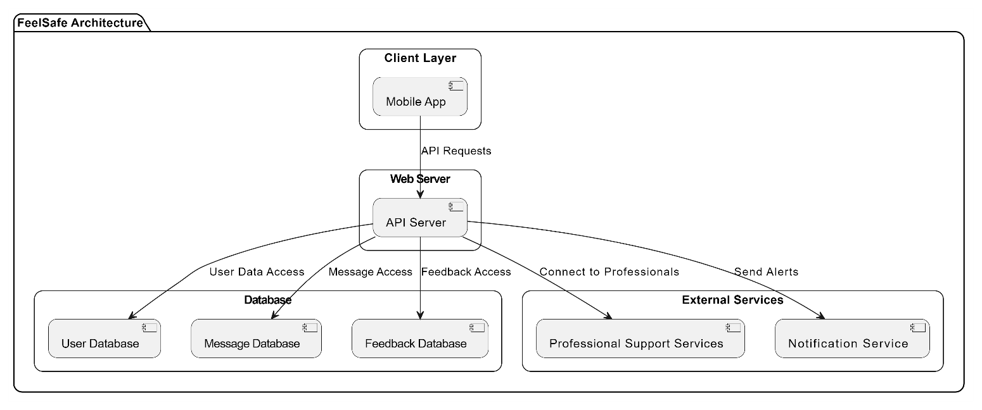

Methodology

1) System Design and Architecture
The system architecture of FeelSafe was designed with a focus on simplicity, user experience, and data privacy. The app is built on Android using Kotlin for the front-end and Firebase for the back-end. The architecture follows a client-server model, where the Android client interacts with Firebase to manage user authentication, store shared data, and provide real-time communication features.

User Interface: The app interface is developed using Kotlin and XML for the user interface. The client handles user inputs (such as sharing feelings anonymously), interacts with the Firebase database, and displays real-time notifications.

Backend Integration: The backend services are hosted on Firebase, which offers Firestore for real-time database management, Firebase Authentication for secure login and registration, and Firebase Cloud Messaging (FCM) for push notifications. Firebase acts as the central hub for storing user data, ensuring data privacy, and managing communication between users and professionals.

2) User Authentication:
User authentication is essential for ensuring the privacy and security of app users. The app uses Firebase Authentication, which supports multiple login methods, including email/password and social media logins such as Google and Facebook. User credentials are securely stored in Firebase and protected with hashing algorithms. Users are also required to create anonymous profiles, ensuring that personal identities are not shared during interactions on the platform.

3) Anonymous Sharing of Feelings:
One of the core functionalities of the FeelSafe app is allowing users to share their feelings anonymously. This feature is designed with privacy as a top priority. Users can submit their thoughts or emotions without disclosing personal details. The process involves the following steps:

Input: Users can input their feelings through a text-based interface, selecting emotional categories (e.g., happy, sad, anxious, etc.).

Processing: The submitted data is processed through Firebase Firestore, where the text is stored anonymously, and the content is visible only to empathetic listeners or community members, as per the app's guidelines.

Moderation: Inappropriate content is flagged and can be reported for review by admins to ensure the safety of the community. This involves a moderation system powered by Firebase, which stores flagged content for review and decision-making.

4) Reporting Inappropriate Behavior:
To maintain a safe and supportive environment, users are empowered to report inappropriate behavior. The app includes an easy-to-use reporting feature where users can flag harmful comments or interactions. The report includes options for specifying the nature of the issue (e.g., harassment, bullying, inappropriate language). These reports are stored in Firebase Firestore for admin review.
The moderation system is managed by an admin role, which can access and take action on reports. Reports are stored separately from the main shared content to protect user anonymity.

5) Access to Professional Resources:
The app integrates a section dedicated to professional mental health resources. Users can access a curated list of articles, videos, helplines, and counselling services. The resources are retrieved in real-time using Firebase Cloud Storage, allowing for easy updates and maintenance by app administrators.
The app also includes push notifications via Firebase Cloud Messaging to alert users of new resources or updates on professional services, keeping them engaged and informed.

6) Push Notifications and User Engagement:
To keep users engaged and informed, the app uses Firebase Cloud Messaging (FCM) to send push notifications. Notifications are sent for critical events such as:

New Resources: Informing users about newly added mental health resources.

Inappropriate Behaviour Reports: Alerts to admins when reports are submitted for review.

These notifications are designed to encourage interaction without overwhelming the user, maintaining the balance between engagement and user comfort.
.
7) Analytics and Monitoring:
The app integrates Firebase Analytics to track user behavior, engagement patterns, and system performance. This data is collected anonymously and used to improve the user experience by identifying which features are most commonly used, how often users interact with the platform, and where the app may need refinement. The analytics also support the monitoring of app usage, providing insights into the effectiveness of features such as anonymous sharing and professional resource access.

8) Testing and Evaluation:
The app undergoes continuous testing throughout its development. This includes unit testing, UI testing, and integration testing to ensure that all functionalities perform as expected. User feedback is also collected through beta testing phases, which helps to identify any usability issues or bugs before the public release.

9) Data Privacy and Security:

The system enforces strict privacy controls, leveraging Firebase security rules and HTTPS protocols to protect user data. The Firebase security rules are set to ensure that data access is restricted based on user authentication status, while maintaining full user anonymity. Data transmission is encrypted using industry-standard protocols, safeguarding against potential breaches.

Research and Discussion

1) Importance of Anonymity and Privacy:
A key component of successful mental health apps is ensuring user anonymity and privacy. Studies have shown that the fear of judgment and stigma often prevents individuals from seeking mental health support (Kuiper et al., 2019). Many users prefer to share their thoughts and emotions anonymously, as it allows them to open up without concerns of discrimination or exposure. A well-designed mental health app must integrate features that maintain privacy while fostering a supportive and empathetic environment.

2) Background and Literature Review:
Mental health has become an increasingly important public health concern, with rising numbers of individuals facing conditions such as depression, anxiety, and stress. According to research, mental health apps have emerged as effective tools to help individuals manage their well-being through self-care, psycho-education, and community support (Firth et al., 2017). These apps aim to provide accessible, real-time support to individuals, offering a wide range of features such as mood tracking, self-help resources, and chat-based services. Mental health apps also have the potential to reduce barriers such as stigma, lack of accessibility, and the fear of judgment when seeking help.

3) Need for Professional Resources and Peer Support:
While peer support offers an informal but valuable form of emotional assistance, access to professional mental health resources remains crucial for users who may require more structured interventions. Studies show that users benefit from a hybrid model, where they can engage in peer support while also having access to certified professionals for guidance (Hoh et al., 2018). For example, individuals experiencing more severe mental health symptoms might need access to licensed counsellors, hotlines, or other mental health resources that provide expert help. An effective mental health app must therefore integrate both professional and peer support systems to cater to a wide range of user needs.

Additionally, professional resources serve as a reliable source of information for users who may be navigating complex mental health challenges. By offering educational materials, therapy guides, and direct connections to mental health professionals, the app can help bridge the gap between self-help and professional care. This integration of expert guidance ensures that users not only receive emotional support from their peers but also benefit from evidence-based treatment recommendations when necessary.

Discussion Section:

1)User-Centered Design and Usability
In the design of any digital health solution, user experience plays a critical role in determining the effectiveness and adoption of the app. User-centered design (UCD) principles emphasize the importance of building apps that are easy to navigate, accessible, and responsive to users' needs. For a mental health app, this means designing an intuitive interface that allows users to access features like mood tracking, anonymous sharing, and resources with minimal effort. According to Ratzan et al. (2020), apps with simple, user-friendly interfaces are more likely to be adopted by users and become part of their daily routine.

The design must also take into account users with varying levels of technological proficiency. Some individuals may not be tech-savvy, and a complicated interface could deter them from engaging with the app. Therefore, it is crucial to provide an intuitive and simple experience that caters to all users. Regular usability testing can help identify potential pain points, ensuring that the app evolves to meet the changing needs of its user base while maintaining high standards of accessibility and functionality.

2) Privacy Concerns and Security Measures:
Privacy and security are primary concerns for users of digital health apps, especially when it comes to mental health. Individuals are often hesitant to share personal information, especially when dealing with sensitive topics such as mental illness. Therefore, mental health apps must incorporate stringent security measures to ensure user trust. For instance, end-to-end encryption is essential for protecting data from unauthorized access, ensuring that only the intended parties can view the information. Additionally, cloud storage services must comply with data protection regulations to safeguard user data at all times.
Furthermore, security goes beyond just technical measures—it also involves transparency and communication with users. Mental health app developers must provide clear terms of service and privacy policies that explain how user data will be collected, stored, and used. This transparency fosters trust and reassures users that their data is safe. As Raupach et al. (2017) highlight, privacy controls are not just a technical feature but a central aspect of creating a supportive and secure environment for users to engage in mental health management.

3)Technological Advancements and Backend Integration:
The success of a mental health app also depends on its technical infrastructure. Firebase, a cloud-based platform from Google, offers a scalable solution for real-time data management and user authentication. By using Firebase, the FeelSafe app can store user data securely and deliver notifications in real time. Firebase Authentication allows users to sign in with email, Google, or other social platforms, ensuring that login processes are both secure and user-friendly. Additionally, Firebase Cloud Messaging (FCM) can be integrated to send push notifications, keeping users engaged and informed about new messages or app updates.

Another key feature of Firebase is its support for real-time updates, which is critical for the anonymous sharing feature. By leveraging the Firestore database, the app can allow users to post and view anonymous messages in real time, fostering a dynamic and responsive user experience. This level of technical sophistication ensures that the app remains fast, reliable, and capable of supporting a growing user base without compromising on performance or data security.

4)Challenges and Opportunities for Improvement:
Despite its promising features, developing and maintaining a mental health app comes with several challenges. One of the primary concerns is ensuring that the app scales effectively as the user base grows. An increase in users may lead to more data and increased traffic, which could strain the backend infrastructure. Additionally, ensuring that all interactions within the app remain anonymous while still fostering a sense of community can be difficult. Striking the right balance between user anonymity and active engagement remains an ongoing challenge in app development.

However, these challenges also present opportunities for improvement. By continually gathering user feedback and conducting regular updates, the app can evolve to meet changing user needs. Incorporating machine learning algorithms for personalized mental health recommendations is another avenue for future development. As more data is collected, the app could provide increasingly personalized support, helping users navigate their mental health journey with tailored advice and interventions.

Results

Figure 2: The login screen offers a simple and welcoming interface for both returning and new users. It provides multiple login options, including email and third-party services like Google and Facebook, making the sign-in process flexible and convenient. Additionally, new users have the option to sign up if they don’t already have an account. The design is clean and minimalistic, ensuring a smooth user experience while focusing on accessibility and ease of use..

Figure 3: The messaging module allows users to express their thoughts and emotions with a straightforward interface. Users can share their current mood, select relevant topics, and add highlights to their messages for greater visibility. It provides options for customization and privacy settings, ensuring users can share content in a way that feels comfortable to them. The design emphasizes user engagement while maintaining a balance between simplicity and functionality, making it easy for individuals to connect with others in a supportive environment.

Figure 4: The professional support module provides a safe and supportive environment for users seeking mental health assistance. It offers essential resources like wellness and safety centers, along with help guides and blogs aimed at providing guidance. Users can access these resources to seek support, share their experiences, or connect with others. The module emphasizes user safety and encourages those in urgent need to seek emergency assistance. The design of the module ensures ease of navigation, allowing users to engage with various mental health resources while feeling secure and supported.

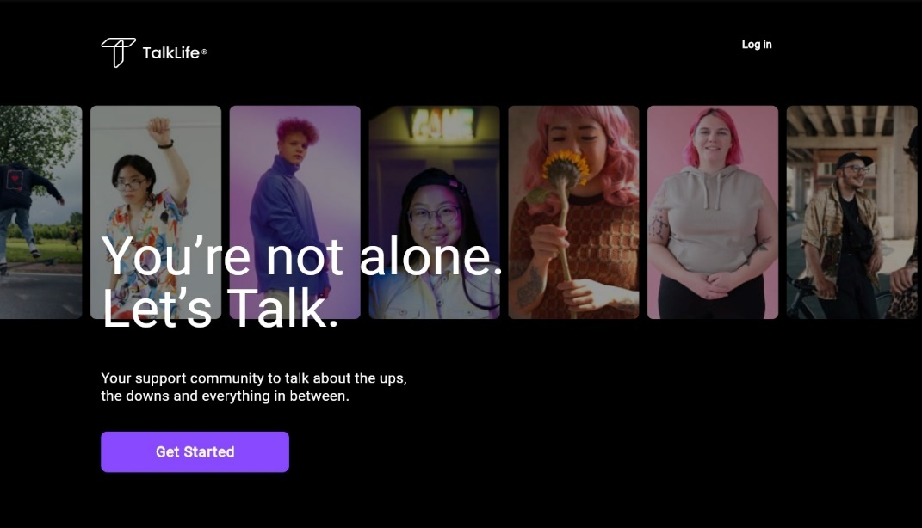

Fig 1:Overview

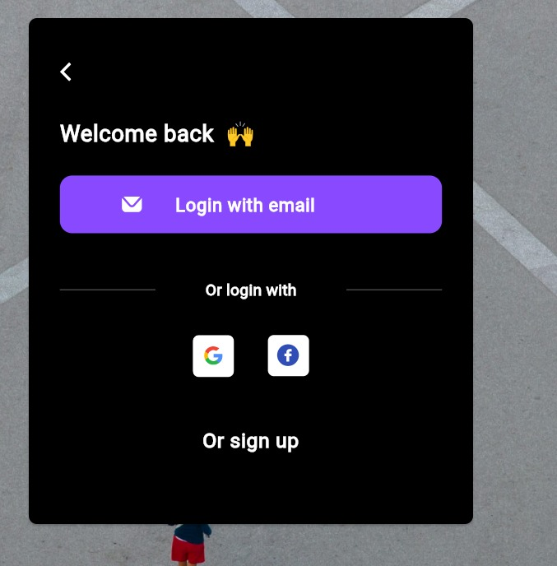

Fig 2: Screenshot of Home page

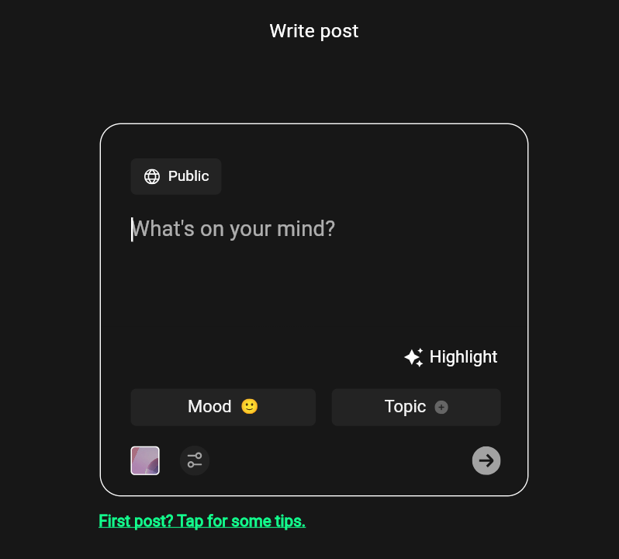

Fig 3: Screenshot of Messaging Interface

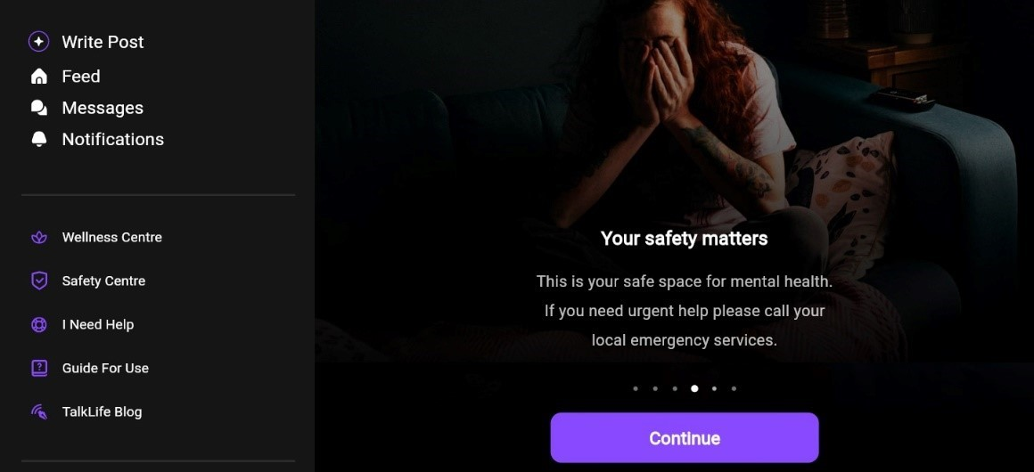

Fig 4: Screenshot of Professional support

Conclusion
The development of the FeelSafe app marks a significant step toward addressing the mental health challenges faced by individuals in today's fast-paced society. By providing a platform for anonymous sharing, peer support, and access to professional resources, the app aims to create a safe and supportive environment for users to express their emotions without fear of judgment. The integration of robust privacy controls ensures that users’ data is protected, fostering trust and encouraging openness. Through the combination of advanced technology, user-centered design, and an empathetic approach, FeelSafe has the potential to contribute meaningfully to the mental well-being of its users. This initiative not only bridges the gap between individuals and mental health resources but also promotes an open dialogue around mental health, reducing stigma and fostering a sense of community.

Future Works

Looking ahead, there are several areas for enhancement and expansion of the FeelSafe app. Future work will focus on incorporating machine learning algorithms to provide personalized recommendations for mental health resources and support based on users' input. Additionally, integrating advanced analytics and user feedback mechanisms will help refine the app’s features and improve user experience over time. Another key area of development will be expanding the app’s reach to cater to more diverse user groups, including different age ranges, cultural backgrounds, and specific mental health conditions. Furthermore, plans for multilingual support, real-time chat features, and partnerships with mental health professionals will enhance the app’s usability and accessibility. These future improvements will ensure that FeelSafe remains a relevant and impactful tool for mental health support in the years to come.

References

[1] Olivia Oswald Lim, David Habsara Hareva,Eden Steven,Dionysius Sentausa,Frentsen Adeputra Abineno Companion: Mental Health Mobile Applications for Students.IEEE Nov 2022.

[2]E.S Mendis, L.W Kasthuriarachchi, H.P.K.L Samarasinha, Sanvitha Kasthuriarachchi, Samantha Rajapaksa ‘Mobile Application for Mental Health Using Machine Learning’, IEEE Nov 2022.

[3] Malaika Samuel; C.P. Shirley,
"Mindset, An Android-Based Mental Wellbeing Support Mobile Application. IEEE Oct 2023.

[4] Shiqi Yang, Ping Zhou2, Kui Duan3, M. Shamim Hossain, MohammedF. Alhamid.”emHealth: Towards Emotion Health Through Depression Prediction and Intelligent Health Recommender System”.

[5] Shagun Saboo; Srishti Gupta; Isha Nailwal; Rithik Gandhi; Sameer Rana. “Diagnosing Mental Health Patient While Maintaining Anonymity”.IEEE Dec 2021.

[6] AKM Jahangir Majumder; Jack Wilson Dedmondt; Sean Jones; Amir A. Asif.” A Smart Cyber-Human System to Support Mental Well-Being through Social Engagement”.IEEE Sep 2020.

[7] Moath Erqsous; Faith Lovell; Benita Abraham; Andrew Ngo; Matthew Louis Mauriello.” Poster: Opportunities and Challenges in Mental Health Mobile Applications”.IEEE Aug 2024.

[8] Maria D. Venegas; Jessica M. Brooks; Amanda L. Myers; Marianne Storm; Karen L. Fortuna.” Peer Support Specialists and Service Users’ Perspectives on Privacy, Confidentiality, and Security of Digital Mental Health”.IEEE Mar 2022.

[9] Yudhistya Ayu Kusumawati; Ni Putu Anggie Michaelia; Sidharta Sidharta,“Mobile Application-Based Psychological to Improve College Student Mental Health”.IEEE Dec 2023.

[10] Dr Amanda Commons Treloar, “MyPsyDiary Pro: Track & Improve Mental Health.” Google Play, 2016.

IEEE conference templates contain guidance text for composing and formatting conference papers. Please ensure that all template text is removed from your conference paper prior to submission to the conference. Failure to remove template text from your paper may result in your paper not being published.

